Audio specialist Sennheiser enters automotive sector
Karma and Sennheiser to showcase first in-car AMBEO sound system at Monterey Car Week

Sydney/Wedemark, 8 August 2019 – Sennheiser has entered the automotive sector with an AMBEO immersive audio solution for in-car entertainment and communication in collaboration with Southern California-based luxury automaker, Karma Automotive. Meticulously engineered using highest-grade microphone and loudspeaker technology and 3D audio expertise, the AMBEO sound system provides impressively enveloping sound and clear audio for phone calls. The system can first be experienced as a technology showcase on a new 2020 Karma Revero GT during Monterey Car Week from August 15 to 18.

Karma will present a fully immersive AMBEO sound experience technology showcase | 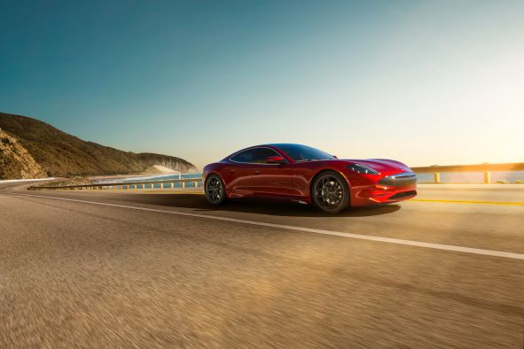

“We are extremely pleased to be taking the unique immersive audio experience of AMBEO to automobiles, and to be doing so with Karma Automotive, who put their development focus on electric vehicles,” said Daniel Sennheiser, co-CEO of Sennheiser. “With Karma, we are combining the future of mobility with the future of audio enjoyment.”

Co-CEO Andreas Sennheiser added: “We set out with the aim to create nothing less than the best-in-class sound experience. The system we designed will amaze with its authentic immersive sound, voice intelligibility, and possibilities for sound personalization.”

“At Karma Automotive we pride ourselves in creating immersive driving experiences through global relationships and technology partners such as Sennheiser,” states John Maloney, Chief Revenue Officer of Karma Automotive. “Karma’s Pebble Beach technology showcase of the AMBEO sound system in our 2020 Revero GT illustrates cutting-edge audio technology possibilities for the future.”

Karma Automotive’s Monterey Car Week activation is located on Peter Hay Hill at Pebble Beach and is open Thursday 15 through Sunday 18 August.

Distributed sound system
The AMBEO sound system on board the 2020 Karma Revero GT consists of a multi-channel loudspeaker set-up arranged in two main layers plus a subwoofer to provide authentic sound immersion anywhere in the cabin. To make this experience complete, the vehicle’s headrests have been integrated into the loudspeaker concept.

Crucially, the ability to enjoy breathtaking immersive sound does not require specific 3D audio sources – the system’s AMBEO upmix algorithm can turn any stereo material into an immersive experience. Audio sources and levels are managed via a convenient graphical user interface, which allows the driver and passengers to personalize the sound according to their preferences. The interface also lets you determine the preferred degree of immersiveness, and your position within the sound stage.

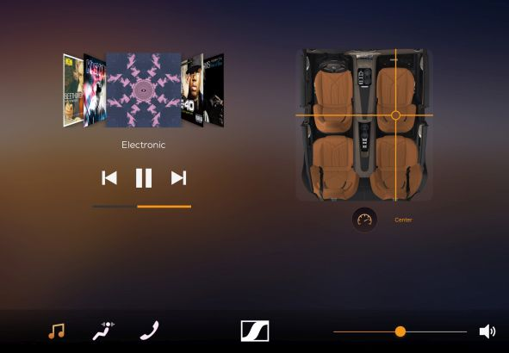 | Example screen of the AMBEO user interface

Finally: Intelligible phone calls thanks to beamforming microphone arrays
With the AMBEO system, clear phone conversations in the car are no longer a dream. The system employs beamforming technology to actively focus on the speaker, with the beamforming microphone arrays integrated into both sides of the cabin. The result is precise capture of the voice, while wind, engine and tire noise is efficiently attenuated. The other passengers can join the phone conversation, or continue listening to their music or film audio undisturbed. This solution has yet another advantage: It enables relaxed, clear communication between everyone in the car.

An engineering feat
Sennheiser engineers worked more than two years on developing and fine-tuning the AMBEO technology for the automotive sector. “The main challenge was to bring immersive high-quality audio into the complex and difficult environment of the car, which is quite unlike our usual use cases for immersive audio and beamforming technologies,” said Dr. Véronique Larcher, Director AMBEO Immersive Audio at Sennheiser. “We almost had to start from zero, with the objective of not only bringing a good solution to market, but creating the very best available. This AMBEO system now combines the gold-standard AMBEO upmix algorithm for immersive audio with high-quality, elevated sound reproduction and the latest beamforming technology for clear communications.”

Visit the Karma activation on Peter Hay Hill at Pebble Beach during Monterey Car Week to experience the unique AMBEO immersive sound system from Thursday 15 through Sunday 18 August.

About Sennheiser
Shaping the future of audio and creating unique sound experiences for customers – this aim unites Sennheiser employees and partners worldwide. Founded in 1945, Sennheiser is one of the world’s leading manufacturers of headphones, loudspeakers, microphones and wireless transmission systems. Since 2013, Sennheiser has been managed by Daniel Sennheiser and Dr. Andreas Sennheiser, the third generation of the family to run the company. In 2018, the Sennheiser Group generated turnover totaling €710.7 million. www.sennheiser.com

About Karma Automotive
Karma Automotive designs, engineers, and markets luxury electric vehicles, all from its Southern California base of operations. Founded in 2014 and employing nearly 1,000 people worldwide, Karma Automotive is committed to elevating and growing the luxury mobility experience for its customers and draws on global relationships and technology partners to achieve this. The Revero is a luxury electric vehicle powered by dual electric motors that embodies Karma’s goals of offering leading automotive design, technology, customization and an outstanding customer experience. Every Revero is created with great individual care and world-class craftsmanship at the Karma Innovation and Customization Center in Moreno Valley, Calif.

Learn more about Karma Automotive at www.karmaautomotive.com or visit the password-free Karma Newsroom at www.karmanewsroom.com for the latest press releases, videos and images.

Sennheiser Global PR Contacts

Mareike Oer Stephanie Schmidt
mareike.oer@sennheiser.com stephanie.schmidt@sennheiser.com
+49 (5130) 600 – 1719 +49 (5130) 600 – 1275

Sennheiser Local PR Contacts

Heather Reid
heather.reid@sennheiser.com
+61 448 119 609

Karma PR Contacts

Matthew Clarke, PR Director Natasha Overin, PR Specialist
maclarke@karmaautomotive.com noverin@karmaautomotive.com
+1 949.416.8575 +1 949.629.7539

